Arsalaan Ansari (aaa2325)

**HW 4**

Problem 1a)

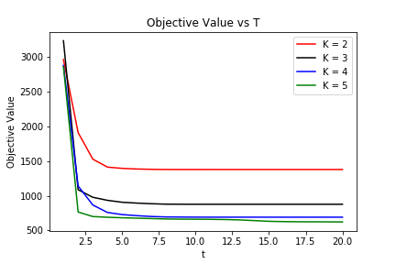

Problem 1b)

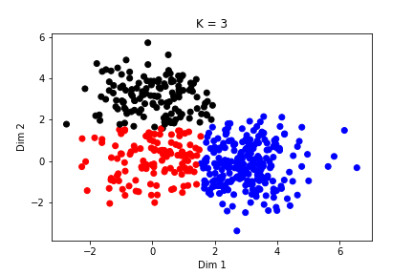

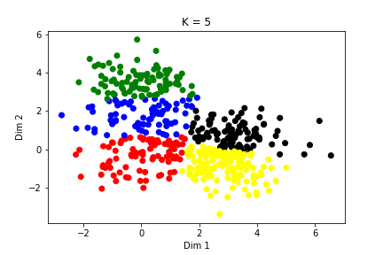

Problem 2a)

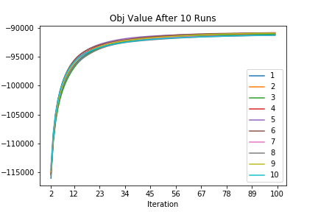

**iter** **objective** **testRSME**

6 -90866.5 1.12507

5 -90917.7 1.12871

4 -90918.2 1.13025

9 -90937.8 1.11918

3 -91101.1 1.12356

1 -91125.1 1.12092

2 -91133.4 1.09794

7 -91283.1 1.13065

10 -91291 1.10263

8 -91309.7 1.10439

Problem 2b)­­­

10 closest Movies with distances:

|  |  |  |
| --- | --- | --- |
| Star Wars: **Distance** | My Fair Lady: **Distance** | Goodfellas: **Distance** |
| Empire Strikes Back, The (1980):  **0.311447** | Sound of Music, The (1965):  **0.571044** | Full Metal Jacket (1987):  **0.685489** |
| Return of the Jedi (1983):  **0.608870** | Victor/Victoria (1982):  **0.738695** | Apocalypse Now (1979) :  **0.726574** |
| Raiders of the Lost Ark (1981):  **0.632709** | Sabrina (1954)  **0.845459** | Shining, The (1980):  **0.760094** |
| Usual Suspects, The (1995):  **0.706876** | Beauty and the Beast (1991):  **0.851743** | Once Upon a Time in the West (1969):  **0.810819** |
| Princess Bride, The (1987):  **0.823608** | Cinderella (1950):  **0.973586** | Godfather: Part II, The (1974):  **0.849388** |
| Manon of the Spring (Manon des sources) (1986):  **0.827772** | American in Paris, An (1951)  **0.975458** | Bonnie and Clyde (1967) :  **0.849582** |
| My Man Godfrey (1936):  **0.911561** | Return of Martin Guerre, The (Retour de Martin...:  **0.977926** | Cool Hand Luke (1967) :  **0.873371** |
| Blues Brothers, The (1980) :  **0.912880** | Parent Trap, The (1961) :  **1.012469** | Good, The Bad and The Ugly, The (1966) :  **0.890342** |
| Terminator, The (1984):  **0.927361** | Winnie the Pooh and the Blustery Day (1968):  **1.013403** | Short Cuts (1993)  **0.895831** |
| Indiana Jones and the Last Crusade (1989):  **0.938632** | Mary Poppins (1964):  **1.036256** | Casino (1995) :  **0.920561** |